Lesson 2: Variables

Introduction
In this lesson the learners will be introduced to variables as well as getting more confident with sequences. The lesson will start with a story that includes variables; learners will replace the variable names with the values they refer to when they reach the relevant point in the story. Learners will then be given a Scratch program where they will work in pairs to predict, run, investigate, and modify. The lesson will conclude with an activity requiring the learners to trace the value of a variable in an algorithm.

Learning objectives
- Define a variable as a name that refers to data being stored by the computer
- Recognise that computers follow the control flow of input/process/output
- Predict the outcome of a simple sequence that includes variables
- Trace the values of variables within a sequence
- Make a sequence that includes a variable

Key vocabulary
Variables, sequencing, subroutines, commands, execute, input, process, output, storage, tracing

Preparation
Subject knowledge:

- An understanding of sequencing and variables
- An understanding of the blocks that become available when variables are created in Scratch
- It would be beneficial for you to know how to create variables and subroutines in Scratch to help debug any mistakes that learners may make. There is no requirement for learners to be able to independently create variables and subroutines in this lesson.

Possible misconceptions:

M1: A variable can store multiple values; it may store the history of values assigned to it

M3: A variable is merely a pairing of a name with a value. It is not stored within the computer

M4: An assignment statement such as a= b+1 stores an equation in memory or stores an unresolved expression b + 1 in memory

M7: Assignment statements such as a = b work in both directions

Misconceptions from: Sorva, J. (2018) Misconceptions and the beginner programmer. In: Barendsen, E., Schulte, S., Sentance, S. (eds.) Computer science education: perspectives on teaching and learning in school. London, Bloosmbury, pp. 171-188.

Pedagogy:

- PRIMM: Use to explore variables and sequencing in a chatbot program
- Pair programming: To complete the ‘Chat with Big Ed’ activity worksheet using driver/navigator roles. Swap roles regularly (i.e. every five minutes)

You will need:
- Access to Scratch 3 either via the web (https://scratch.mit.edu/) or offline (https://scratch.mit.edu/download/). Check that your school filters do not block any part of this website.
  - Chat with Big Ed: version to give to learners (ncce.io/biged1)
  - Chat with Big Ed: completed version (ncce.io/biged1-complete)
- Slide Deck
- A2 Solutions - Investigate answers
- A2 Worksheet - Chat with Big Ed
- AP Worksheet - What’s the temperature?
- L2 Homework

Assessment opportunities
The main assessment in this lesson will be in ‘Chat with Big Ed’ activity (PRIMM). You will be able to assess them by recording their progress in the modify steps. It is not expected that all learners will complete the ‘modify’ steps, however, all learners should complete the ‘investigate’ steps as a minimum. The final activity will assess their ability to trace a variable and recognise that the value of a variable can change during program execution.

Outline plan
Please note that the slide deck labels the activities in the top right-hand corner to help you navigate the lesson.

*Timings are rough guides
Starter activity  (Slides 2-10)  15 mins | Variables storytime  Inform the learners that they are going to hear a story. Throughout the story there are a few words that they will hear a number of times. Ask the class to think of the words they want to use in the story. They will need to pick a country, town, hero, villain, and a sister, all of which will act as our variable names. Computers are good at storing data and it is the job of the learners to play the role of the computer and to try and remember all of the data that has been defined against the variable names.  The teacher will read out the story and every time the learner sees a variable name they should all shout out the word that they have linked to that variable name.  Midway through the story, they must change the word linked to the variable name TOWN.  Define the term ‘variable’ formally to the class. Make sure that you emphasise that the name refers to data being stored by the computer, to help address the common misconception M3 (a variable is merely a pairing of a name with a value. It is not stored within the computer). The data was only stored once and yet the learners retrieved the data from their memory when it was needed, much like a computer would retrieve the data from its memory (RAM).  Allow time for learners to think and write down the answers to the questions on slide 11, before discussing their answers with the person next to them. Go through the answers with the class.  Q2. Addresses misconception M1 (a variable can store multiple values; it may store the history of values assigned to it). Highlight that the learners had to redefine the TOWN variable twice in order to store different data. It did not hold both at the same time, or remember the previous value it stored.
Activity 1  (Slide 12)  3 mins | Input, process, output  Use the illustration to highlight to the learners the concept of input/process/output. Often a computer will take inputs as well as producing an output. A good example of this is showing the learners that when you use a keyboard and mouse, it is inputting data into the computer to be processed and the output is visible on the computer monitor.  Highlight to the learners that storage is also important (as evident in the starter activity). The computer stores data and needs to retrieve it to be processed at the appropriate times.
Activity 2  (Slides 13–19)  30 mins | Chat with Big Ed: PRIMM  Pair learners and instruct them to complete all tasks on the activity 2 worksheet. It is important that they discuss and work collaboratively, but they should complete their own worksheet and put the answers into their own words as they understand it.  Predict and run: 5 minutes  Allow 5 minutes for the learners to predict what they think the code will do. They will then run the code and compare what happened to their predictions. Reiterate that there is no expectation that their prediction should be correct; it is an important part of their learning to understand why what happened might have been different from their prediction.  Investigate: 15 minutes  Allow the learners 15 minutes to work their way through the ‘investigate’ questions. The questions are designed to allow the learners to investigate:  - The relationship between the subroutine and when/how it is called  - The use of variables in the program  - Sequencing and that variables must be defined before they are called  If learners have completed the questions before the end of 15 minutes, allow them to move on to the ‘modify’ steps.  After 15 minutes, run through the answers to the investigate questions with the class. You may want to allow your learners to make changes to their answers in a different coloured font, e.g. if their answers were incorrect or they want to add more detail to their response after you have explained the answers.  Modify  The modify tasks require the learners to add more questions to the Big Ed program. It is not expected that all learners will complete the modify step. How far they get into the questions can form part of your assessment of their progress.
Plenary  (Slides 20–26 )  5 mins | Tracing the value of the variable (What’s the temperature?)  The aim of the activity is for the learners to look at a sequence made in Scratch that uses a variable called ‘temperature’. Their task is to trace the variable and write down the current value of the variable each time there is an output i.e. every time they see the following block:  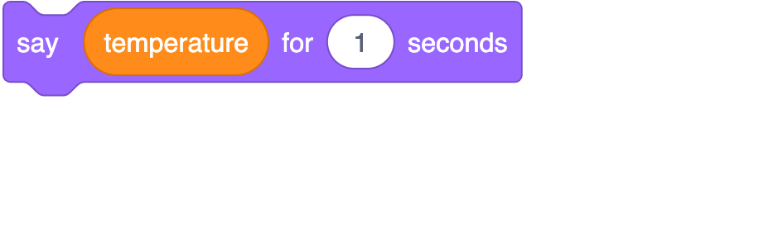  Distribute the worksheets for the learners to complete (on paper or electronically). Allow 5 minutes to complete before running through the slides to show the answers.
Homework | Distribute the questions for homework. There are four multiple choice questions that will help you diagnose whether the misconceptions have been addressed. Each question requires an answer as well as space for the learner to justify why they chose that answer. This will also help you gain an understanding of what learners do and don’t know and to avoid guesswork.

Resources are updated regularly — the latest version is available at: ncce.io/tcc.

This resource is licensed under the Open Government Licence, version 3. For more information on this licence, see ncce.io/ogl.

